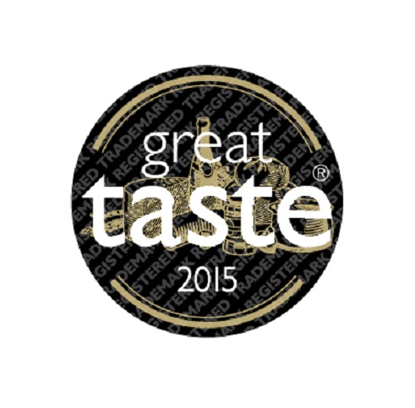
P R E S S R E L E A S E
Great Taste 2015 announces new stars and ROUSSAS DAIRY is a winner
The world’s most coveted blind-tasted food awards, Great Taste, has just released the Great Taste stars of 2015 and ROUSSAS DAIRY is amongst the producers celebrating, as its products have won 6 “precious” gold stars in total, and are now able to proudly carry the little gold and black Great Taste logo.

More specifically Roussas Dairy products have been awarded as follows:
Roussas Barrel Aged Feta P.D.O. – 3 stars
Roussas Organic Feta P.D.O. - 2 stars
Roussas Feta cubes in EVOO with herbs – 1 star

In addition to these awards Roussas Barrel Aged Feta P.D.O. has been included in this year’s Great Taste Top 50 Foods. To be in this lofted company practically means that a product has been part of an exhaustive judging process defining the best 50 foods you should be buying and tasting.

On the occasion of this recognition, the company's Management stated: “Winning these awards certifies the high quality and the amazing taste of our products. We are deeply honoured that our devotion to traditional cheese making techniques and our continuous effort to provide products of superior quality and exceptional taste is rewarded. We will remain faithfully dedicated to principles inherited from our forefathers and continue to set high standards in fine tasting, authentic Greek dairy products for cheese connoisseurs all over the world”

Judged by over 400 of the most demanding palates belonging to food critics, chefs, cooks, restaurateurs, producers and a host of food writers and journalists, Great Taste is widely acknowledged as the most respected food accreditation scheme for artisan and speciality food producers. When a product wears a Great Taste label it carries a badge of honour but more importantly, the Great Taste logo is a signpost to a wonderful tasting product – hundreds of judges have worked tirelessly to discover the very best, through hours and hours of blind-tasting a total of 10,000 different foods and drinks.

Recognised as a stamp of excellence among consumers and retailers alike, Great Taste values taste above all else, with branding and packaging ignored. Whether it is cheese, ale, steak or chutney being judged, all products are removed from their wrapper, jar or bottle before being tasted. The judges then savour, confer and re-taste to decide which products are worthy of a 1-, 2- or 3-star award.

There were 10,000 Great Taste entries this year and of those products, 130 have been awarded a 3-star, 597 received a 2-star and 2,382 were awarded a 1-star accolade. The panel of judges included Masterchef judge and restaurant critic Charles Campion, TV presenter and cook, Aggie Mackenzie, Great British Bake Off winner, Frances Quinn, Masterchef the Professionals finalist, Adam Handling, food buyers from Harrods, Selfridges, Waitrose and Marks & Spencer, and chefs including James Golding, Chef Director of The Pig hotel group, who have together tasted and re-judged the 3-star winners to finally agree on the 2015 Top 50 Foods, the Golden Fork Trophy winners and the new 2015 Supreme Champion.

Finally on Monday 7 September, at a nail-biting Awards’ Dinner at the Royal Garden Hotel, London, the great and the good from the world of fine food will gather to hear who has won the Golden Fork Awards and the final applause will be reserved for the Great Taste Supreme Champion 2015.

Date: August 5th 2015
For more information please contact: Mrs. Sophia Apostolaki, s.apostolaki@roussas.gr

Great Taste Awards Press Enquiries:
Amy Brice at Freshly Ground PR; email amy@freshlygroundpr.co.uk or call 07717 893123.
Notes for editors:
What is Great Taste?
Great Taste is the largest and most trusted accreditation scheme for specialty and fine food & drink. Established in 1994, it encourages and mentors artisan food producers, offering a unique benchmarking and product evaluation service leading to an independent accreditation that enables small food and drink businesses to compete against supermarket premium own label brands.

Since 1994 over 100,000 products have been evaluated. This year 10,000 products were blind-tasted by panels of specialists: top chefs, cookery writers, food critics, restaurateurs and fine food retailers.

What are Great Taste judges looking for?
They’re looking for great texture and appearance. They judge the quality of ingredients and how well the maker has put the food or drink together. But above all, they are looking for truly great taste.

How do they work?
Working in small teams, experts taste 25 foods in each sitting, discussing each product as a coordinating food writer transcribes their comments directly onto the Great Taste website which producers access after judging is completed. Over the years, numerous food businesses, start-ups and well established producers have been advised how to modify their foods and have subsequently gone on to achieve Great Taste stars.

Any food that a judging team believes is worthy of Great Taste stars is judged by at least two further teams. Only when there is a consensus will an award be given – that means at least 16 judges will have tasted every accredited product. For a Great Taste 3-star award, every single judge attending the session, which can be as many as 40 experts, must unanimously agree the food delivers that indescribable ‘wow’ factor.

What should consumers look for?
The logo. The Great Taste symbol is their guarantee a product has been through a rigorous and independent judging process. It’s not about smart packaging or clever marketing – it’s all about taste.

